LAB 11 - Exercise:

Dynamic Routing Roles in a Scalable Network

Learning Objectives

Upon completion of this lab, you will be able to:

* Determine the number of subnets needed using VLSM technique.
* Determine the number of hosts needed.
* Design an appropriate addressing scheme.
* Assign addresses and subnet mask pairs to device interfaces and hosts.
* Examine the use of the available network address space.
* Determine how dynamic routing could be applied to the network.

Scenario

Given the network address 202.1.3.0/24 to subnet and provide the IP addressing for the network shown in Figure 1. The network has the following addressing requirements:

* The LAN 1 require 4 IP addresses. /28
* The LAN 2 require 7 IP addresses. /28
* The LAN 3 require 10 IP addresses. /28
* The LAN 4 require 11 IP addresses. /28
* The LAN 5 require 30 IP addresses. /27
* The link between routers require an IP address for each end of the link. /30 /30 /30

**Figure 1** Topology Diagram

1: Examine the Network Requirements.

Examine the network requirements. Keep in mind that IP addresses will be needed for each of the LAN interfaces.

2: Design an IP Addressing Scheme.

Based on scenario above, determine all usable IP addresses using Variable Length Subnet Masking (VLSM) technique and complete Table 1.

**Table 1** IP Addressing scheme

| **Network** | **Subnet Address** | **First Usable Host Address** | **Last Usable Host Address** | **Broadcast Address** |
| --- | --- | --- | --- | --- |
| LAN1 | 202.1.3.16 | 202.1.3.17 | 202.1.3.30 | 202.1.3.31 |
| LAN2 | 202.1.3.32 | 202.1.3.33 | 202.1.3.46 | 202.1.3.47 |
| LAN3 | 202.1.3.48 | 202.1.3.49 | 202.1.3.62 | 202.1.3.63 |
| LAN4 | 202.1.3.64 | 202.1.3.65 | 202.1.3.78 | 202.1.3.79 |
| LAN5 | 202.1.3.96 | 202.1.3.97 | 202.1.3.126 | 202.1.3.127 |
| R1R2 | 202.1.3.4 | 202.1.3.5 | 202.1.3.6 | 202.1.3.7 |
| R1R3 | 202.1.3.0 | 202.1.3.1 | 202.1.3.2 | 202.1.3.3 |
| R2R3 | 202.1.3.8 | 202.1.3.9 | 202.1.3.10 | 202.1.3.11 |

3: Assign IP Addresses to the Network Devices

Use the Packet Tracer to build the topology and assign the appropriate addresses to the device interfaces. Document the addresses to be used in the Addressing Table provided in Table 2.

**Table 2** Addressing Table

|  |  |  |  |  |
| --- | --- | --- | --- | --- |
| **Device** | **Interface** | **IP Address** | **Subnet Mask** | **Default Gateway** |
| R1 | Fa0/0 | 202.1.3.33 | 255.255.255.248 | N/A |
| S0/0/0 | 202.1.3.1 | 255.255.255.252 | N/A |
| S0/0/1 | 202.1.3.5 | 255.255.255.252 | N/A |
| R2 | Fa0/0 | 202.1.3.49 | 255.255.255.248 | N/A |
| Fa0/1 | 202.1.3.65 | 255.255.255.248 | N/A |
| Fa0/1/0 | 202.1.3.97 | 255.255.255.248 | N/A |
| S0/0/1 | 202.1.3.6 | 255.255.255.252 | N/A |
| S0/1/1 | 202.1.3.10 | 255.255.255.252 | N/A |
| R3 | Fa0/0 | 202.1.3.17 | 255.255.255.240 | N/A |
| S0/0/0 | 202.1.3.1 | 255.255.255.252 | N/A |
| S0/1/1 | 202.1.3.9 | 255.255.255.252 | N/A |
| PC1 | NIC | 202.1.3.18 | 255.255.255.240 | 202.1.3.17 |
| PC2 | NIC | 202.1.3.34 | 255.255.255.240 | 202.1.3.33 |
| PC3 | NIC | 202.1.3.50 | 255.255.255.240 | 202.1.3.49 |
| PC4 | NIC | 202.1.3.66 | 255.255.255.240 | 202.1.3.65 |
| PC5 | NIC | 202.1.3.98 | 255.255.255.224 | 202.1.3.97 |

4: Test the Network Design.

If all routers on the new network are requested to be configured by RIPv2 Routing protocol, use the Packet Tracer and apply your addressing scheme. Check to see that all devices on directly connected and remote networks can communicate (ping) each other. Complete all tasks in **complete network schematic diagram** and **packet tracer file**.

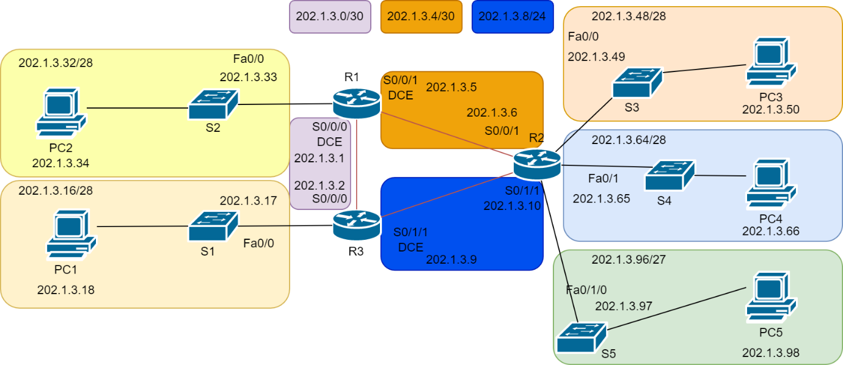

Network Schematic Diagram